H&S Policy Statement

McCue are committed to ensuring, as far as is reasonably practicable, the Health, Safety & Welfare of its employees, visitors and members of the public who may be affected by our actions or omissions.

The Company shall adhere to the relevant Health & Safety Legislation pertinent to the country the work is undertaken as well as complying with ISO 45001:2018 all other requirements and regulations.

The Company shall provide, so far as is reasonably practicable: -

- A safe place of work

- Safe Plant & Equipment

- Safe Systems of Work

- Appropriate information, instruction, training, supervision, consultation and participation

- Suitable protective clothing and equipment

- Commitment to provide safe and healthy working conditions for the prevention of injury and ill health.

Day to day responsibility for ensuring this policy is put into practice is delegated to the HSEQ Manager and they also shall be responsible for implementing and monitoring emergency procedures, monitoring accident reporting and training with employees in the Company.

McCue commit to continually eliminate hazards and reduce OH&S risks so far as reasonably practicable.

All employees shall give their co-operation to the support of this policy statement?

All employees will be protected from reprisals when reporting incidents, hazards, risks or opportunities

The Health & Safety Statutory Notice poster shall be displayed in the Company and on site managed by the company.

Health & Safety objectives will be set annually by the board to drive continual improvement in health and safety performance of the organisation.

This policy shall be reviewed once every 12 months, and updated as necessary.

Copies of this Policy are available for all staff, visitors and Health & Safety Inspectorate.

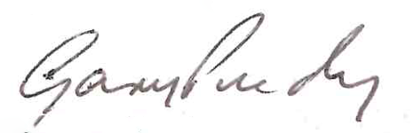

Signed:

Gary Purdy
Managing Director Date: May 2021

